EXPERIMENT 3 :

clc;
clear;
q1 = input('Enter the charge q1=');
q2 = input('Enter the charge q2=');
epsilon = 8.854e-12;
k = 1/(4*pi*epsilon);
r = linspace(0.1,10,100);
F = k*q1*q2./(r.^2);
disp('Force at r = 1 m is:');
disp(k*q1*q2/(1^2));
plot(r,F,'LineWidth',2);
xlabel('Distance (m)');
ylabel('Force (N)');
title('Force between two electric charges');

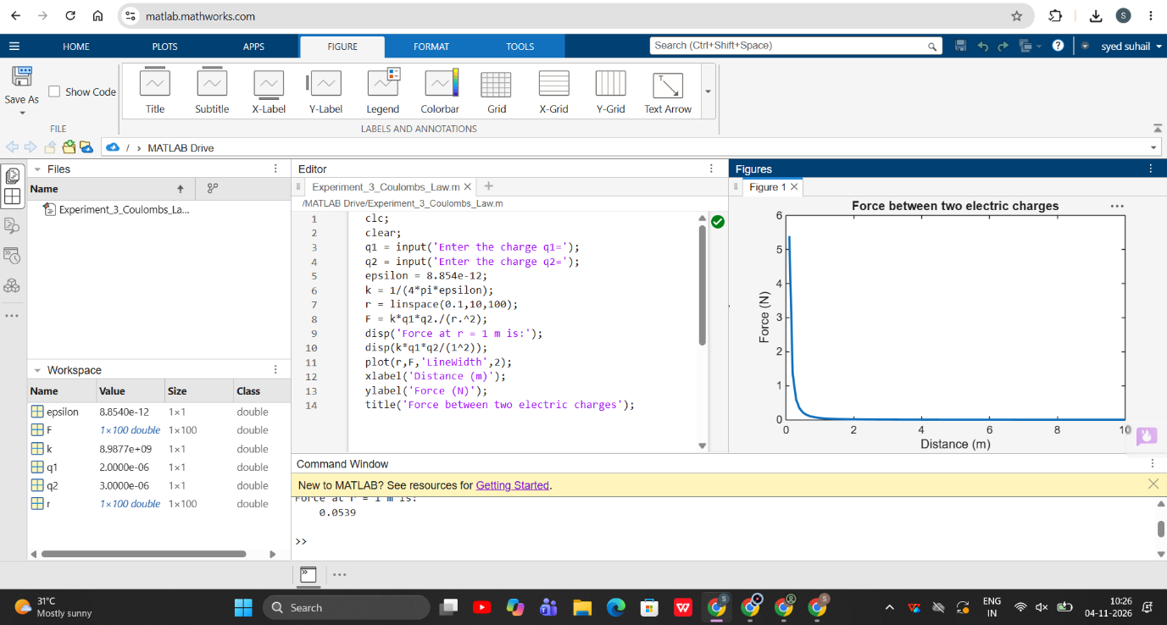

EXPERIMENT 3 TEST CASE 2 :

clc;
q1 = 5e-6;
q2 = 2e-6;
epsilon = 8.854e-12;
k = 1/(4*pi*epsilon);
r = linspace(0.5,5,100);
F = k*q1*q2./(r.^2);
plot(r,F,'LineWidth',2);
xlabel('Distance (m)');
ylabel('Force (N)');
title('Force between two charges (different magnitudes)');

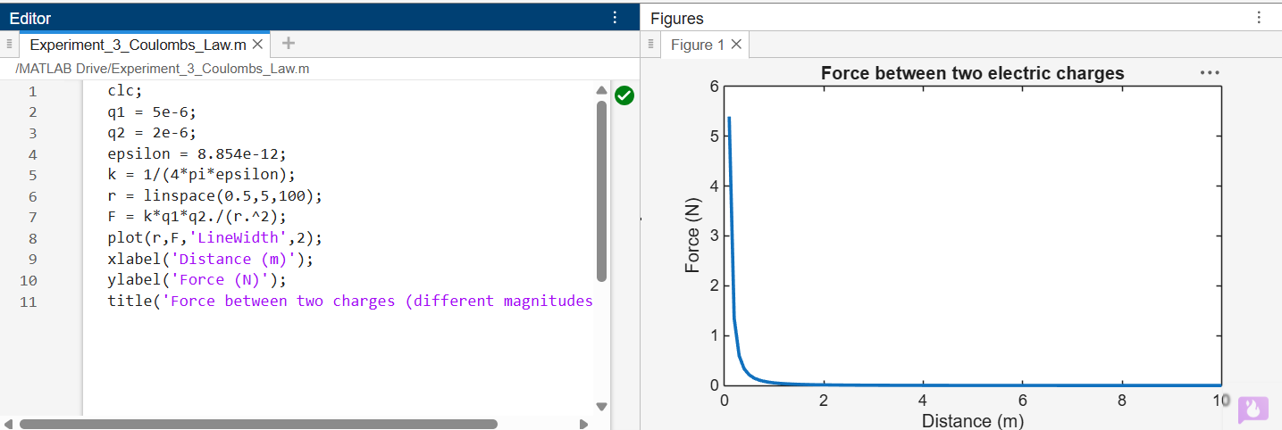

Test case (iii) Determination and plotting of force per unit length between two parallel
conductors with varying distance
Code:
clc;
mu0 = 4*pi*1e-7;
I1 = 5;
I2 = 10;

d = linspace(0.1,10,100);
F = (mu0*I1*I2)./(2*pi*d);
plot(d,F,'LineWidth',2);
xlabel('Distance (m)');
ylabel('Force per unit length (N/m)');
title('Force between two parallel
conductors');


